**Download Xampp**

Open [h**ttps://www.apachefriends.org/download.html**](https://www.apachefriends.org/download.html) and download latest version for your operating system.

Install Downloaded software

Open Xampp Admin panel and start apache and mysql service

Close the Xampp Admin panel and open browser

In browser addressbar enter url : localhost/phpMyAdmin

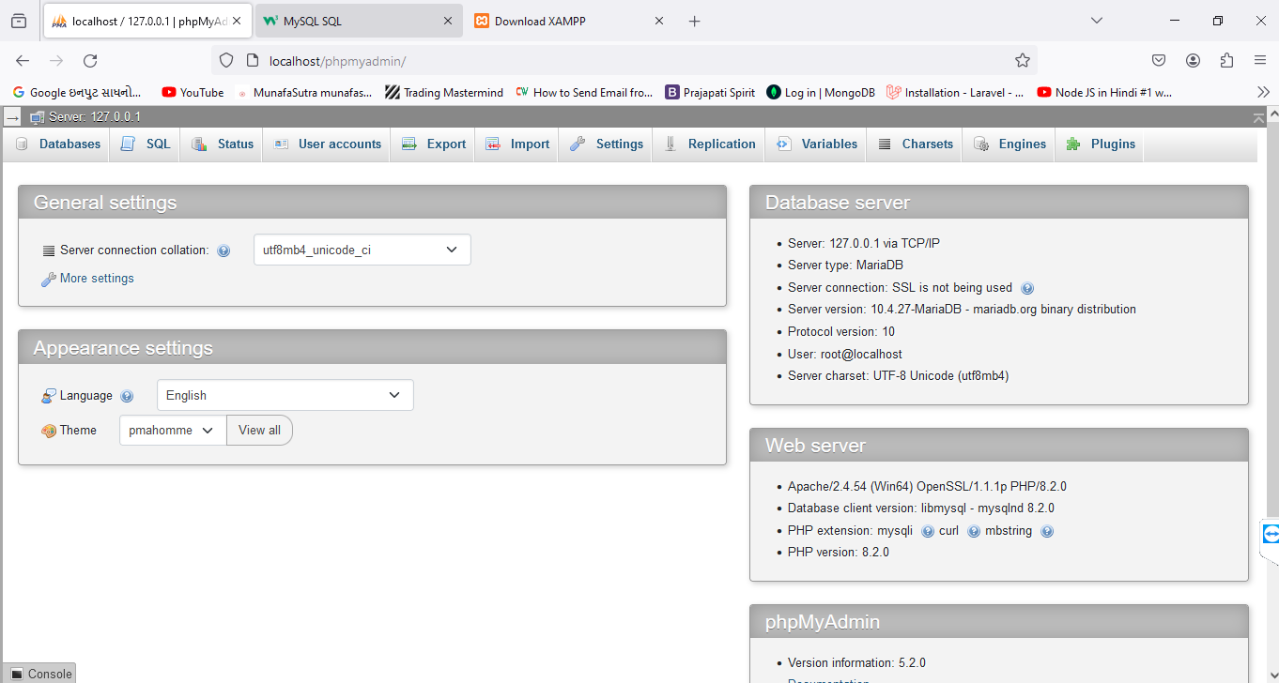

**MySQL Tutorial**

MySQL is a widely used relational database management system (RDBMS).

MySQL is free and open-source.

MySQL is ideal for both small and large applications.

# Introduction to MySQL

MySQL is a very popular open-source relational database management system (RDBMS).

## What is MySQL?

* MySQL is a relational database management system
* MySQL is open-source
* MySQL is free
* MySQL is ideal for both small and large applications
* MySQL is very fast, reliable, scalable, and easy to use
* MySQL is cross-platform
* MySQL is compliant with the ANSI SQL standard
* MySQL was first released in 1995
* MySQL is developed, distributed, and supported by Oracle Corporation
* MySQL is named after co-founder Monty Widenius's daughter: My

## Who Uses MySQL?

* Huge websites like Facebook, Twitter, Airbnb, Booking.com, Uber, GitHub, YouTube, etc.
* Content Management Systems like WordPress, Drupal, Joomla!, Contao, etc.
* A very large number of web developers around the world

## Show Data On Your Web Site

To build a web site that shows data from a database, you will need:

* An RDBMS database program (like MySQL)
* A server-side scripting language, like PHP
* To use SQL to get the data you want
* To use HTML / CSS to style the page

# MySQL RDBMS

## What is RDBMS?

RDBMS stands for Relational Database Management System.

RDBMS is a program used to maintain a relational database.

RDBMS is the basis for all modern database systems such as MySQL, Microsoft SQL Server, Oracle, and Microsoft Access.

RDBMS uses [SQL queries](https://www.w3schools.com/sql/default.asp) to access the data in the database.

## What is a Database Table?

A table is a collection of related data entries, and it consists of columns and rows.

A column holds specific information about every record in the table.

A record (or row) is each individual entry that exists in a table.

Look at a selection from the Northwind "Customers" table:

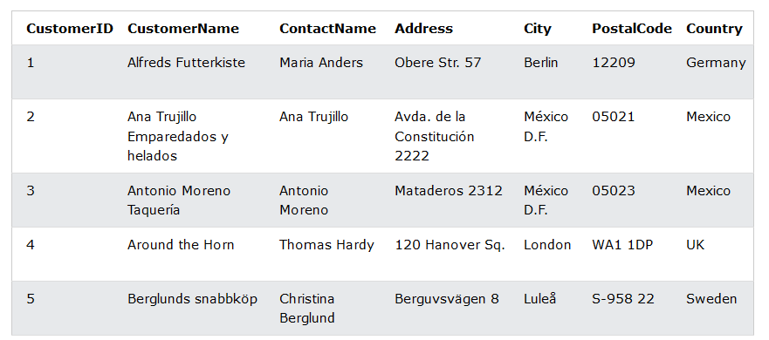

The columns in the "Customers" table above are: CustomerID, CustomerName, ContactName, Address, City, PostalCode and Country. The table has 5 records (rows).

## What is a Relational Database?

A relational database defines database relationships in the form of tables. The tables are related to each other - based on data common to each.

Look at the following three tables "Customers", "Orders", and "Shippers" from the Northwind database:

### Customers Table

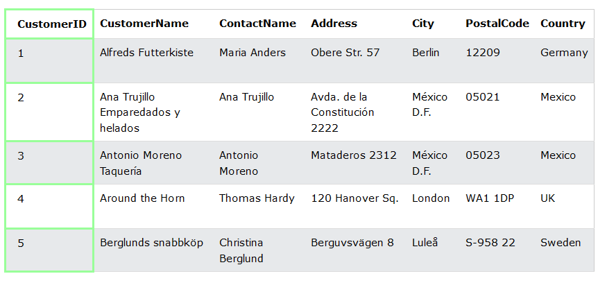

The relationship between the "Customers" table and the "Orders" table is the CustomerID column:

### Orders Table

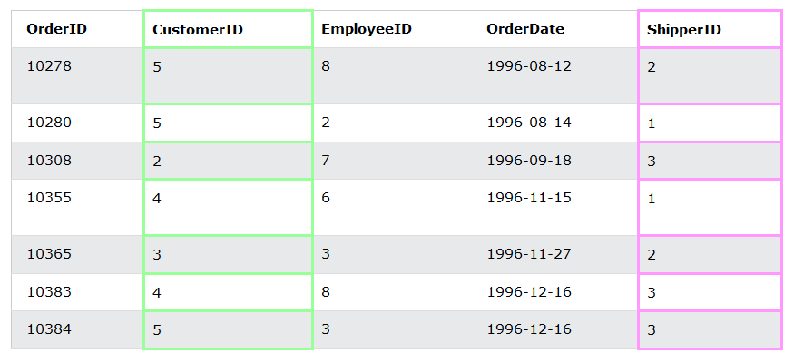

The relationship between the "Orders" table and the "Shippers" table is the ShipperID column:

### Shippers Table

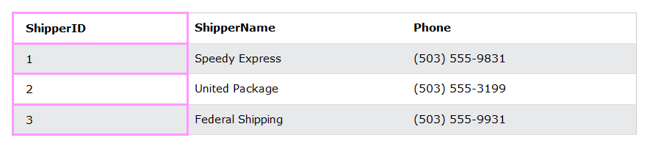

Before begin with MYsql Tutorial you need to create new Database and table with some of the data.

Open database section from localhost/phpMyAdmin -> then select create database section and enter your required database name then press create.

After successfully creation of new database, you will be redirected to newly created database page.

Create new table as following

Enter table name -> students -> create 8 columns

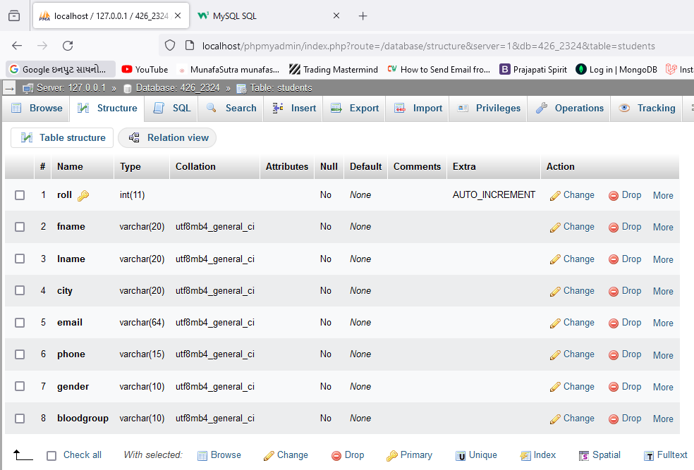

Create above table and add some of the data as below

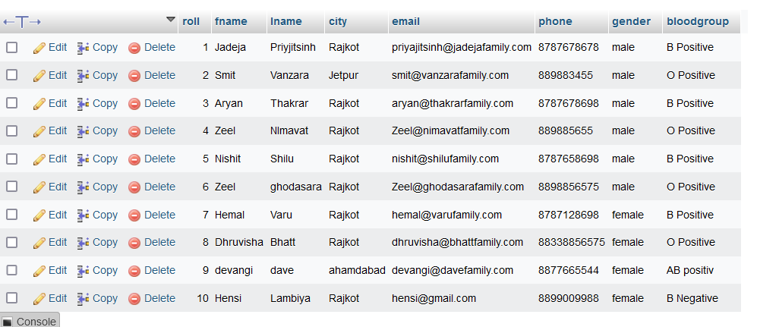

# MySQL SQL

## What is SQL **(Structured Query Language)**?

SQL is the standard language for dealing with Relational Databases. SQL is used to insert, search, update, and delete database records.

## How to Use SQL

The following SQL statement selects all the records in the "Customers" table:

### Example

SELECT * FROM Customers;

SELECT * from students;

## Keep in Mind That...

* SQL keywords are NOT case sensitive: select is the same as SELECT

In this tutorial we will write all SQL keywords in upper-case.

select * from students;

SELECT * from students;

## Semicolon after SQL Statements?

Some database systems require a semicolon at the end of each SQL statement.

Semicolon is the standard way to separate each SQL statement in database systems that allow more than one SQL statement to be executed in the same call to the server. In this tutorial, we will use semicolon at the end of each SQL statement.

## Some of The Most Important SQL Commands

* SELECT - extracts data from a database
* UPDATE - updates data in a database
* DELETE - deletes data from a database
* INSERT INTO - inserts new data into a database
* CREATE DATABASE - creates a new database
* ALTER DATABASE - modifies a database
* CREATE TABLE - creates a new table
* ALTER TABLE - modifies a table
* DROP TABLE - deletes a table
* CREATE INDEX - creates an index (search key)
* DROP INDEX - deletes an index

# MySQL SELECT Statement

## The MySQL SELECT Statement

The SELECT statement is used to select data from a database.

The data returned is stored in a **result table**, called the **result-set**.

### SELECT Syntax

SELECT column1, column2, ...  
FROM table_name;

Here, column1, column2, ... are the field names of the table you want to select data from.

SELECT roll, fname, lname from students

SELECT roll, fname, lname, city from students;

If you want to select all the fields available in the table, use the following syntax:

SELECT * FROM *table_name*;

SELECT * FROM students;

## SELECT * Example

The following SQL statement selects ALL the columns from the "Customers" table:

### Example

SELECT * FROM Customers;

## The MySQL SELECT DISTINCT Statement

The SELECT DISTINCT statement is used to return only distinct (different) values.

Inside a table, a column often contains many duplicate values; and sometimes you only want to list the different (distinct) values.

### SELECT DISTINCT Syntax

SELECT DISTINCT column1, column2, ...  
FROM table_name;

SELECT DISTINCT city from students

## SELECT Example Without DISTINCT

The following SQL statement selects all (including the duplicates) values from the "Country" column in the "Customers" table:

SELECT city from students;

SELECT COUNT(DISTINCT city) FROM students

# MySQL WHERE Clause

## The MySQL WHERE Clause

The WHERE clause is used to filter records.

It is used to extract only those records that fulfill a specified condition.

### WHERE Syntax

SELECT column1, column2, ...  
FROM table_name  
WHERE condition;

SELECT * FROM students WHERE city = 'rajkot'

SELECT * FROM students WHERE roll > 5

SELECT * FROM students WHERE roll = 5;

SELECT * FROM students WHERE roll <> 5;

SELECT * FROM students WHERE not roll = 5;

**Note:** The WHERE clause is not only used in SELECT statements, it is also used in UPDATE, DELETE, etc.!

## Text Fields vs. Numeric Fields

SQL requires single quotes around text values (most database systems will also allow double quotes).

However, numeric fields should not be enclosed in quotes:

SELECT * from students WHERE gender = 'male'

SELECT * from students WHERE gender = male

SELECT * from students WHERE roll = 8

SELECT * from students WHERE roll = '8';